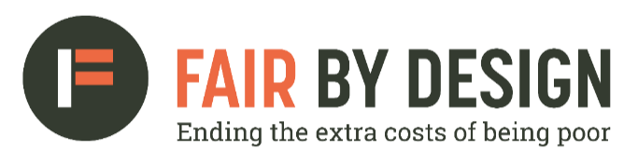

HEAD OF POLICY: FAIR BY DESIGN

JOB DESCRIPTION AND PERSON SPECIFICATION

Job title: | Head of Policy: Fair By Design
Purpose of the role: | Alongside FBD’s Director lead the strategy, planning and delivery of FBD’s Policy work.
Governed by: | The Barrow Cadbury Trust Board with advisory input from the Fair by Design Steering Group
Reports to: | Fair By Design Director
Direct reports: | None
Salary: | £47,013 – £56,415 pa full time + up to 10% contributory pension
Contract: | Fixed term contract of 3 years (with the possibility of renewal).
Location: | Barrow Cadbury Trust offices, central London, Vauxhall.  We operate hybrid working with a minimum of two days in the office/field.  You must be eligible to work in the UK before applying for this role.

Introduction

People in poverty pay more for essentials such as energy, insurance and credit. This is known as the poverty premium. Fair By Design (FBD) is a highly successful influencing programme dedicated to ending the extra costs of being poor. FBD is part of the Barrow Cadbury Trust. It is an influencing, not a grants programme.
We are looking for a talented individual with an outstanding track record of successfully delivering impactful policy programmes to join our team. Using your skills and experience you will help us to achieve our mission of eliminating the poverty premium by ensuring our policy work is thorough, relevant and timely and that our messages are heard by policymakers and those in power.

Responsibilities

- Alongside FBD’s Director lead the strategy, planning and delivery of FBD’s policy work, so we are well placed to influence parliamentarians, civil servants, regulators and social policy influencers such as think tanks. Position FBD as a leading voice on financial inclusion and the poverty premium across a wide set of decision makers.
- Lead the production of key policy outputs, including research and policy reports, briefings, consultation responses.
- Working alongside the Head of External Affairs, help to create compelling policy narratives – articulating clear arguments supported by convincing evidence demonstrating impact.
- Represent Fair By Design at high level stakeholder meetings, events and networks including to the media, as required.
- Work in partnership with external stakeholders to help achieve joint objectives.
- Contribute to governance activities including the drafting of papers for the Barrow Cadbury Trust Board and FBD Steering Group.
- Develop collaborative working relationships throughout Barrow Cadbury Trust.
- Uphold Barrow Cadbury Trust’s Quaker derived social justice value base.
- Uphold and promote the voice of people with lived experience of poverty in our policy and practice work.
- Undertake such other duties as may be reasonably required.

Person specification

Skills, Knowledge and Experience
- Initiative – you must be a self-starter who can drive an impactful policy programme.
- Progressively responsible experience in a relevant position or sector, including a demonstrable record of achieving impact via policy programmes.
- Experience of leading the development and managing the production of policy outputs (including managing external contractors) including research reports, briefings and consultation responses, with an eye for detail and accuracy.
- Experience of complex research and evaluation including interpreting quantitative and qualitative data.
- Ability to produce written work of a high quality which communicates complex information and ideas in clear, accessible and imaginative ways for different audiences.
- An understanding of and evidenced commitment to diversity, equity and inclusion, including as they relate to FBD’s work.
- Familiar with essential services such as finance, insurance, energy and payments or with a demonstrable passion for social justice work in these sectors.
- Organised workstyle with the ability to prioritise, oversee and manage a number of complex work areas simultaneously and independently, working to agreed timelines.
- Willingness to work within the Barrow Cadbury Trust’s Quaker derived social justice value base.
- Help to ensure that the views, experiences and voices of people with personal experience of poverty and the poverty premium are reflected in our work.
- Work flexibly as a team player and carry out any other duties that may reasonably be required.

Desirable
- Lived experience of poverty and the poverty premium.
- Previous work addressing poverty and/or advocating for consumers in essential services such as energy, insurance, credit and payment systems.

